**Curriculum vitae**

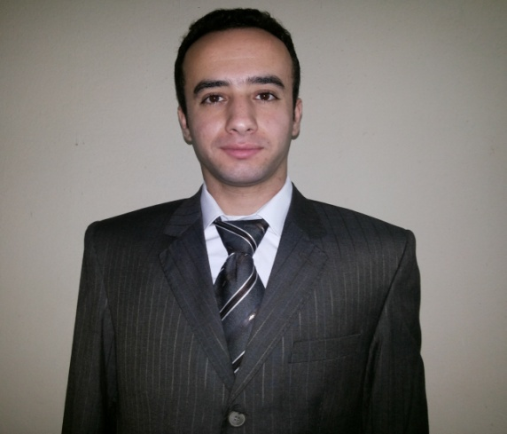

**Personal data :**

|  |  |  |
| --- | --- | --- |
| **Ahmed Hassan Idress Nofal** | **:** | **Name** |
| **28 / 10 / 1991** | **:** | **Date of Birth** |
| **Male** | **:** | **Gender** |
| **El agroudi st – Kafr El Zayat – Gharbia** | **:** | **Address** |
| **040 / 2541702 & 01061097213** | **:** | **Tel . No** |
| **Single** | **:** | **Marital Status** |
| **Completed** | **:** | **Marital Service** |
| **Egyptian** | **:** | **Nationality** |
| **Muslim** | **:** | **Religion** |
| **[ahmed.nofal1911@gmail.com](mailto:ahmed.nofal1911@gmail.com)** | **:** | **E –Mail** |

**Qualifications :**

|  |  |  |
| --- | --- | --- |
| **2013** | **:** | **Graduation** |
| **Bachelor of Commerce** | **:** | **Faculty** |
| **Tanta University** | **:** | **University** |
| **Pass** | **:** | **Graduate** |
| **Fair** | **:** | **Graduate project** |

**Computer skills :**

|  |
| --- |
| **\* I'm skillful in dealing with computer . *very good at excel.**  **\*excel Accounting course.** |

**Languages skills :**

|  |  |  |  |
| --- | --- | --- | --- |
| Speaking | Writing | Reading | Language |
| **Very Good** | **Very Good** | **Excellent** | **English** |

**Personal skills :**

|  |
| --- |
| ***\* Eager to learn , self – motivated , craeative , open – minded , decision maker and cooperative .*** |
| **\* Ability to communicate with people from different levels .** |
| **\* Capable of working hard .** |
| **\* Ability to work under pressure .** |
| **\* No Restrictions for working Abroad .** |

**Work experiences :**

|  |
| --- |
|  |

**\*I've Worked in Accounting field at "jolie ville" hotel in sharm el sheikh**

**\*An Accountant at "hyper techno" in tanta since 12/2015 till now.**