PERSONAL INFORMATION | Mahmoud Tark Mohamed El-samanoudy
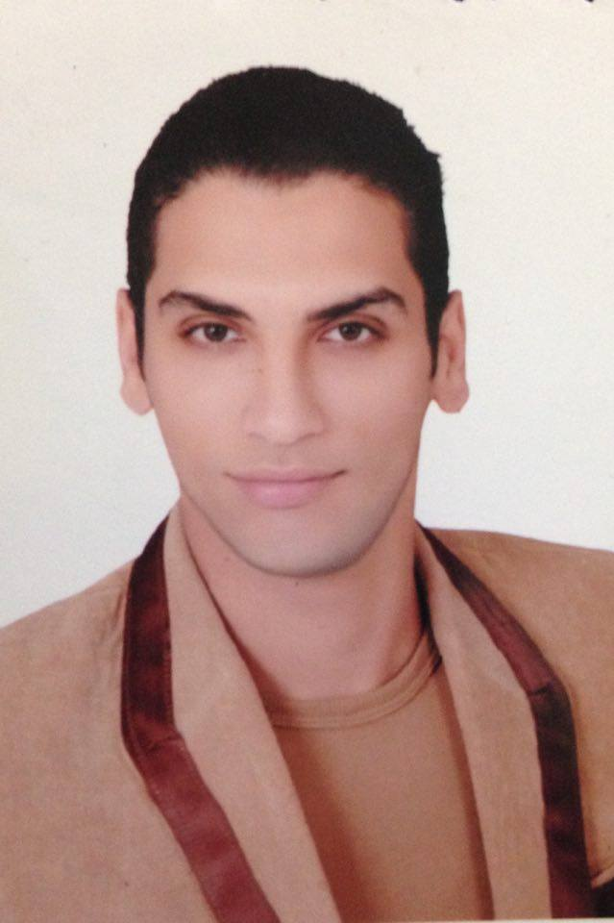 |   El-mahala Elkobra,El- Gharbiya, Egypt.

040-2340142  01152454552 01066382287

mahemoudteto@yahoo.com
Sex male
Date of birth 01/09/1992
Nationality Egyptian

Objective | An ambitious and proactive Architect Engineer seeking a challenging work environment with powerful communication and leadership skills and willing to learn very quickly within the safety limits. A job that will help me in contributing to the growth of prospective employer and offer me a challenging atmosphere and opportunities for learning. It will be Great Honor for me to be a part of your Team.

Education certificate

* I have worked overseeing the design and implementation of the Charity Hospital and residential buildings in Elmahalla Elkoubra ( June 2014 – Mar 2015 )
(from 2010-to 2014) | B.Sc. inArchitecture Engineering  Misr Higher Institute For Engineering &Technology,Mansoura  Graduation project ( research center of Aquaculture )
experience

* I have worked as site engineer and technical office in The engineering divisions of the armed forces. I prepared( the assays, compiling and engineering drawings) of the projects carried out by the The engineering divisions of the armed forces. And projects such as the location of border guards and villages in need . the delivery of drinking water and sanitation. And the construction of a number of 25 building complete finishes. (Mar 2015 - Mar 2016 )
* I have worked as a site engineer in the field of business implementation management (construction, finishing and infrastructure) of the star City compound . Consisting of 39 buildings and 120 villas and built on about 40 acres
( Apr 2016 – Feb 2017 )
* I have worked as project manager in the field of business implementation management (construction, finishing and infrastructure) of the live City compound . Consisting of 8 buildings and mall ( Feb 2017 to now )
PERSONAL SKILLS

Mother tongue(s) | Arabic
Other language(s) | UNDERSTANDING |  | SPEAKING |  | WRITING
Other language(s) | Listening | Reading | Spoken interaction | Spoken production
English | Very good | Very good | Good | Good | Very good

Communication skills | - Good communication skills gained through my experience in Dealing site person

Job-related skills | - supervision  - implementation  - design  - limited Engineering  - Management

Computer skills | - Microsoft operating systems.  - MS Word – Ms Excel – Ms PowerPoint.  - Auto cad  - Photoshop  - Sketch up  - Revit  - Office.

