Name: Ahmed Salah Eldin Hamed Soliman Gaafar.
Tel : 00201065454242/01229787889

Email : Ahmedsalah9060@yahoo.com

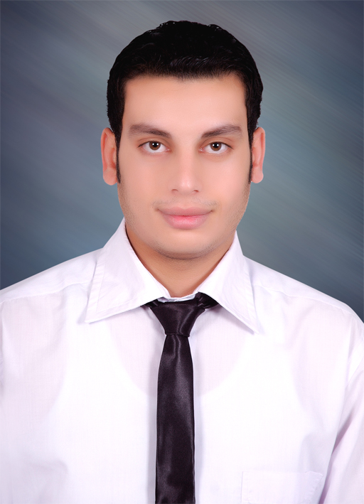

Curriculum Vitae

Personal Data :
- Name  - Date Of Birth  - Military service  - Marital Status  - Nationality | :  :  :  :  : | Ahmed Salah Eldin Hamed Soliman Gaafar.  1/12/1990  Exempted  Single  Egyptian
Contact :
- Address  - Telephone  - E- Mail | :  :  : | Gaafar st,-Berket El-Sabaa, Menofia  Home : 0020482990140  Mobile : 00201065454242/01229787889  Ahmedsalah9060@yahoo.com
Career Objective :
- Looking to obtain a position as an accountant in your esteemed organization where I will have the opportunity to use my accounting education, hands-on experience in a top accounting firm in being a valuable resource in the organization's success as well as further my career prospects.

Education :
- University  - B.S.C  - Graduation Year  - Graduation Grade | :  :  :  : | Faculty of Commerce,Menofia University.  Accounting Department.  May 2011  good (66.9%)

Experiences:
- Training at accounting office as an Auditor FROM 1/10/2011 TO 31/5/2012.

- Working at Proctor&Gamble Company(Speed Ahmed Hassan )as an accountant FROM 1/8/2012 TO 30/9/2013.

- Working at El krom Middle East.Co( BANHA and GIZA NORTH POWER PLANT ) as an accountant FROM 1/11/2013 TO 31/3/2015.

- Working at Soudanco COMPANY as an accountant on the Oracle program FROM 1/5/2015 TO NOW.

Training Course And Languages :
- Course In ICDL SIS Academy.

- Course In Electronic Accounting.

- Native Language Arabic.

- Very Good Command of both written and spoken English.

Computer Skills :
- Highly skilled in windows.

- Highly skilled in computer hardware maintenance.

- Very Good knowledge of Microsoft Office.

- Very Good experience in using internet applications and searching tools.

- Very Good Dealing With Computer Programs And Applications ( Windows - Word - Excel - Power point- Access - Net ).

Personal skills :
- Self-motivation.

- Hard-working person.

- The ability to work under pressure.

All supporting documents are available upon request.

