MOHAMED BAUMIE ABD ELFATTAH MOHAMED
ELMAHALLA ELKOBRA- GHARBIA-EGYPT
TEL/ 01004492235 - 01228014299 - 01115407556
EMAIL/ GEOMOHABDELFATTAH@GMAIL.COM
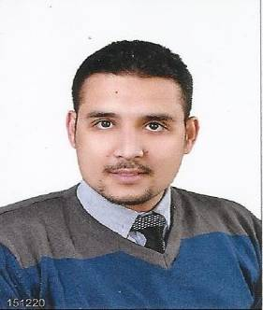
Personal Data:
Name: Mohammed Baumie Abd ELfattah
Gender: Male
Date of birth: 14/11/1985
Marital status: Single
Place of birth: Gharbia . Egypt
Nationality: Egyptian
Military Status: Exempted
Education:
Qualifications: Bachelor of Science.
Al Azhar University. faculty of science.
Geology department. special geology.
Year of Graduation: 2008.
Have license from Union of Arab Geologists and Guild scientists to work as Geologist Engineer.
Language:
Arabic: Mother tongue
English: Good Command(spoken &written).
Computer Skills:
Microsoft Windows. Microsoft Office (Word, Access, Excel and PowerPoint) and most internet programs .

Specialization:
1- Make all field and laboratory tests with follow up results.
2- Supervising the implementation and the receipt of roads and bridges work.
3- Make all technical reports on the state of road and follow up operation.
4- Quality Control laboratories work.
Practical Experience:
1- worked in Soadaa contracting CO. – Cairo – (2007-2009).
- Worked in Mahalla bridge (RING ROAD MAHALLA)
- Worked in Santa bridge ( TANTA- SANTA- ZEFTA RING ROAD)
2- Working in Quality Control laboratories in the General Authority of Road and Bridges (GARBLT) – (MINISTRY OF TRANSPORTATION) work as Geologist Engineer FROM (2010) TILL NOW.
- Supervising on Quality Control laboratories in project ( MAHALLA- KAFER EL SHEIKH) highway road (32 km long- include 8 bridges and 15 tunnels)
- Supervising on Quality Control laboratories and field laboratories in all projects affiliated to the (Central DELTA- GARBLT) as (International coastal road- TAWFEKIA/ KHATTATBA road- TANTA/ DAMMAT road, other) and outside business for other companies.
- Participation in the regulators to adjust the functioning of (Roads directorate)
- Supervising the work of mixers ( pavement(asphalt)- concrete) belong to the (GARBLT) regarding operations and Quality Control
- Getting all courses of the central lap of (GARBLT )
- Getting the (HMA) design methods (MARSHALL) & (SUPER PAVE) and all of their tests.
3- worked in AMERCAN BAKER HUGHES CO. FOR PETROLUM Services – Cairo – (2011-2013).
- Worked as (DATA ENGINEER) IN (Western –Eastern Desert) ( Gulf Of Suez)
- Getting all courses of Baker Hughes co. (Basic mud logging and Gas system Safety and communications skill).

