Curriculum Vitea

Peraonal Info… | 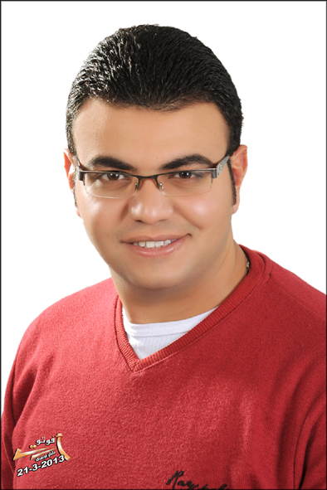
- Name: Maged Ezzat Shawqey.
- Nationality: Egyptian.
- Military Status: Completed.
- Marital State: Married.
- Date of Birth: 6 Dec. 1988.

Objective…
- Civil Engineer positions where I can expend upon my background education and my creative skills with emphasis on continuous accumulation of knowledge.
- Seeking job opportunity in the field of Site engineer where my educational background and training may be put to practice and further development.

Education…
- B.Sc. Of Civil Engineering ( july 2011 ).
- Tanta University , Egypt.
- Grade : Good.
- Graduation Project : Soil Mechanic and Foundations Design.
- Project Grade : Excellent.

Key Courses…
- Auto CAD ( 2D ).
- Sap 2000.
- ICDL.

Experinces…
- Worked at consultant engineering office ( Eng. Hany Khater ) as Designer and Site Engineer from July 2011 to january. 2012 .
- Worked as Project Manager for (2 project) in Saudi Arabia at Qurayat Province and Executive Eng. in Turaif at ( Homood al -Hoshan ) Est. for Constructions from October 2013 to april 2016 at following projects:
- Al-Haditha customs constructions and finishing of the maintenance and operation building.
- Maintenance project of historic and monumental buildings at Al-Qurayat province: ( KAF Palace – Ain Hawas Palace – Emara Palace at AL Haditha – Omar Bin Khattab School ).
- Finishing of Environmental Laboratory at Turaif Province.
- Preparation of Gardens at Turaif Province.
- Asphalt and Pavements at Al-Othaim Mall in Turaif Province.
- Asphalt and Pavements at Rexel Com. Warehouse in Turaif Province.
- Works at EL-Masreen Comp. for Constructions and Finishing from May 2016 till Present at different sites: ( Health Insurance clinics and Hospitals at Al-Gharbia Government ) for preparation works.
Personal Skills…
- Ability To Work Under Pressure & In Teamwork.
- Respect For Labor Leaders.
- Ability to learn new technologies and sciences.
- Adaptable, Leading& Well spoken .
Technical Skills…
- Windows.
- MS Office (Word.Excel &Power Point ).
- Computer Software & Hardware.
- Internet Browsing.

Langauges…
- Arabic : Mother Tonge.
- English : good in both Written and Spoken.

Contact Info…
- Adress : El-Gohary St. off Tereet El-Sheaty St – Tanta – El-Gharbia / Egypt.
- E-mail : magedmaro9@gmail.com
- Phone :002 012 73 205 210 / 002 0102 800 8098

