C . V

Ahmed Mohamed abd El-Aziz qomsan selim . | Name  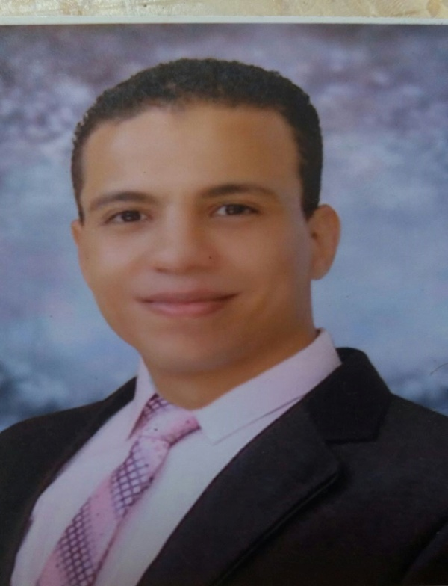
Gharbia - Egypt | Address
25/7/1991 | BirthDate
(040)2018599 | Telephone
01090855521-01111722724 | Mobile
01271960023 | Work Phone
ahmedqomsan2020@gmail.com | E-Mail
Completed | Military service status

Job Objective
Seeking a position that meets my skills in Civil Engineering

Scientific Qualifications
B.Sc. of Civil Engineering (2013)
General Grade:- "very good"
Graduation Project
Soil mechanic & Foundation
Grade :- Excellent

Languages
 | Reading | Writing | Speaking
 | Native | Native | Native | Arabic
 | good | good | good | English

Courses
AutoCAD – SAP – ICDL – SAFE –ETabs – CSI Column | 1
Revit Structure (self learn) | 2

Training
Arab Contractors company | 1
National Authority for Tunnels (NAT) Line 3 | 2

Skills
Good at:  Word – Excel – PowerPoint | Computer
Good at:  AutoCAD – Revit(self learn) – SAP | Programs
- Worked as a Site Engineer in Armed Forces Engineering Authority .    - establishment of 1680 residential units in the social housing project in Khanka and Shubra el-Khaima in qalyoubia Governorate for 20 months .  - Execution of all stages of the project from the stage of drilling until fully delivered .  - Execution of the number of 1100 piles during the stage of the foundations in the number of 11 buildings in Shubra al-Khima .  - Supervise the execution of water, drainage, electricity and roads networks and landscape works .  - Worked as a site engineer in The luxurious housing project (Dar Misr) Badr City for 69 residential buildings as a first and second stage .  - Getting the work of the technical office (shop drawing - Quantity surveying )  - Worked as a site engineer in Palm constructions .    - Establishment of new fever hospital in Mansoura .  - Execution of the work of neighbor support "secant piles" .  - Execution of the work of bored piles . | Experiences
Good in speaking English and working on the site or on the different engineering programs. | Others

"References Available Upon Request"

