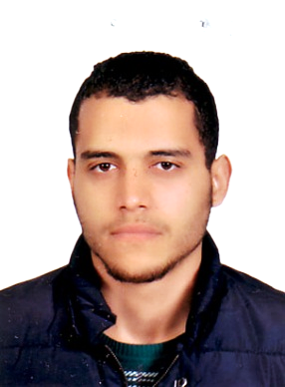**Personal Data:**

      ⮚ **Name: Muhammed Khaled Omran**

      ⮚ **Date Of Birth: 19-3-1993**

      ⮚ **Nationality: Egyptian**

      ⮚ **Military status: Exemption from military service**

ـــــــــــــــــــــــــــــــــــــــــــــــــــــــــــــــــــــــــ

**Address: Gharbiya-tanta-Said Street**

**E-Mail: muhammedomran03@gmail.com**

**Phone number: 01200242803**

ـــــــــــــــــــــــــــــــــــــــــــــــــــــــــــــــــــــــــ

# Objectives:

**Seeking a junior structural engineer position with a construction company or engineering firm that could allow me to get much experience in this field.**

ــــــــــــــــــــــــــــــــــــــــــــــــــــــــــــــــــــــــ

### [Education](https://www.google.com.eg/url?sa=t&rct=j&q=&esrc=s&source=web&cd=6&cad=rja&uact=8&ved=0ahUKEwjlyrjG45HOAhUE2BoKHfDbCmYQFggwMAU&url=https%3A%2F%2Fen.wikipedia.org%2Fwiki%2FEducation&usg=AFQjCNE74mygASc-lJqh0PX9ci7hP9PKKw) :

**• Postgraduate Level**

**⮚ B.Sc. from Civil Engineering Department, Engineering Faculty,**

**AlـAzhar University (Class2016).**

**     ⮚ Graduation Project: Material**

** ⮚ Graduation Project : Good**

** ⮚ Overall rating: Good**

**Learning Experience**

**• working**

**          ➢ Site Engineer at Alamin Company** **Gharbiya-tanta**

ــــــــــــــــــــــــــــــــــــــــــــــــــــــــــــــــــــــــ

**Computer skills:**

**⮚ Revit Structure ⮚ Etabs**

**⮚ csi column  ➢ Sap 2000**

** ⮚ Safe ➢ Auto CAD**

**⮚ Structural Designs by APC Company**

ــــــــــــــــــــــــــــــــــــــــــــــــــــــــــــــ

**Language skills**

**⮚ Mother Tongue: Arabic language.**

**⮚ Other Language: English language (Good).**

ــــــــــــــــــــــــــــــــــــــــــــــــــــــــــــــــــــــــ

**Soft Skills:**

**⮚  work under pressure.**

**⮚ fast learning.**

**⮚ Team work**

**⮚ Time organizer.**

