C.V.

Personal data

- Name : Ahmed Mohammed AboElfetouh Ahmed Nouh.
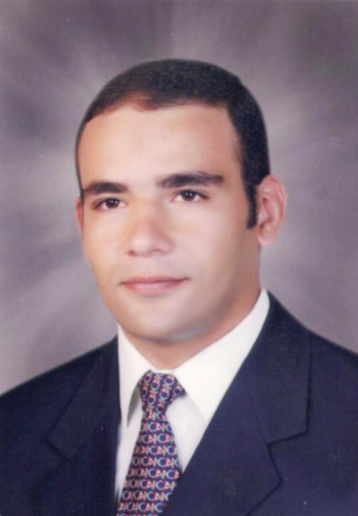
- Date of birth : 23 / 10 / 1984
- Nationality : Egyptian.
- Religion : Muslim.
- Military service : Exempted.
- Mobile : 01006226049  01206680038 - 01144404277
- E-mail : ahmed.m.nouh@gmail.com
Education

- University : Tanta
- Faculty : Commerce
- Department : Accounting
- Graduation Year : 2007
Skills

Computer:
- MS Windows
- MS Office ( Word  Excel  Access  Power Point )
- Accounting Programs.
Language:
- Arabic Language : Mother tongue
- English language : Good
Work experience

- Accountant in Alexandria for Constructions Co.  Talaat Mustafa group  Madinaty project from (September 2008 till now). (Experience certificate available upon request).

Professional experience

General :
- Record in journal.
- Preparing the balance sheet.
- Preparing the income sheet.
- Oversee the companies' accounts.
- Record all accounting operations in computer using MS Excel or instant accounting programs.
- Work in group or alone.
According to Constructions Company:
- Oversee Monthly Payments with Client.
- Preparing and Oversee Subcontractor Payment.
- Account the operating costs.
- Preparing sheets of Salaries and Monthly costs.

Im seeking for highly education level, experience and I want to get work
related to my specialization to have the ability to add something useful.
I’m looking forward to join your team,,,

