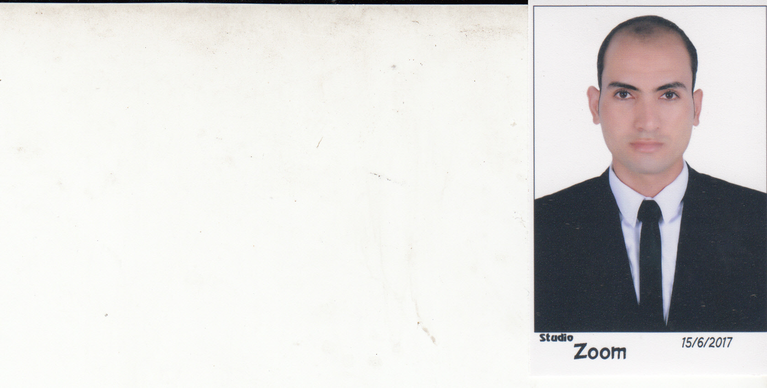
Mahmoud Mohamed Mohamed Soliman Saqr

Personal information

- Tel : 01024501319
- Address : Al-Bagour - Menoufia
- Date of birth : 1/10/1989
- Gender : Male .
- Marital Status : maried .
- Military Status : Completed .
- Nationality : Egyptian .
- Email  mahmoudsakr592@gmail.com

Education ...
- Qualification : bachelor of rights
- Graduation Year : 2011
Skills & Courses
- Personal skills :
- Creative .
- High communications skills .
- Inter active and fast enough to learn new technologies and sciences .
- Working under any pressures and circumstances
- Ability to work in a team
- Development of quality and performance of work

Experiences
1 - Work for 5 years in the field of laboratory tests and quality control
2- Concrete tests
3 - Foundations of soil mechanics
4. Material tests
5. Projects in which I worked /
Sharm El Sheikh Airport - Port Said tunnels - Egyptian Museum
6 - Companies in which I worked /
Bin Laden - Ardman Ace
7- Language: Good English
8. Certificate of ICDL

–

