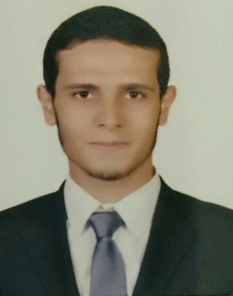

**Abd Elghafar Nabil Ezz Eldien Elbadwy**

|  |
| --- |
| 15thAHMED ORABI STREET MITGHAMR DAKHLIA, FLAT "45". |
| Phone (0111) 2409424 • abdelghafarelbadwy@gmail.com |



**Objective:**

* To seek a challenging and career oriented position in a dynamic organization to enhance my knowledge, skills and contribute towards the success of organization.

**PERSONAL DATA:**

* Name: **Abd Elghafar Nabil Ezzeldien Elbadwy**
* Gender: Male
* DOB: 01/08/1992
* 🖂 Mailing Address: 15th orabi StREET mitghamr dakhlia,FLAT"45".
* E mail: ABDElghafarelBADWY@Gmail.COM
* Mobile: **01112409424**
* Nationality: Egyptian
* Marital Status: Single
* Military status: Exempted
* Driving licence: Existed

**Work experience :**

* Worked for four months at Alandalousconstruction .
* Works for **"AL Bostany Real Estate"New Cairo City since March 2015.**

**Education:**

* **B.S.C**. of **Civil Engineering**, Mansoura University 2014, with grade: "**Very Good**".
* Graduation Project: **Construction** **Project Management**  
  Applied to the construction of **The New "Mit Ghamr" Water Plant**
* **Project Grade:** **Excellent**

**Training****:**

* October 2010: **AutoCAD 2D** Training course at Mansoura university SCC.
* Trained at " MADINATY Project " for two monthsat " July 2012 & 2013 "
* February 2014 : SAP Training course at “Science &Technology Academy”& Also ETABS-SAFE- CSI
* March 2014 : **Primavira**  Training course at **" ITC Academy"**
* March 2014 :REVIT Training course at @Training lab services center

@mans university.

* I have several skills in the **Engineering Survey Works**.

**Skills:**

* Could operate effectively with Microsoft office tools namely word, excel, power point, access.
* Have worked with various versions of Windows Operating system namely Win7 &8 and Win XP.
* Excellent written and communication skills in English.
* Have good problem solving with analytical thinking.
* Open minded to work in complex environment and projects.

[**References**](#References Help)**:**

* A list of references is available on request