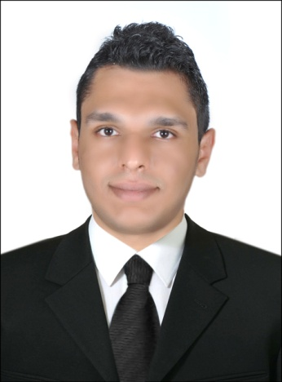

**Basem Tarek Abd El Azeem Ahmed**

**Civil engineer**

**Address**: 1st. Abdo Nassar st. Ain Shams, CAIRO, EGYPT

**Phone** **no**. 01009175688 - (02-21994678)

**E-mail:** basemtarek57@gmail.com

**Date of Birth:** 6/5/1990

**Marital Status:** Single

**Objective**

Seeking a challenging position in a reputable company where my academic background and Interpersonal skills are well developed and utilized. I appreciate working in team work, having the attitude of learning, ready to work under pressure and I want to be innovative in my career.

ــــــــــــــــــــــــــــــــــــــــــــــــــــــــــــــــــــــــــــــــــــــــــــــــــــــــــــــــــــــــــــــــــــــــــــــــــــــــــــــــــــــــــ

**Education**

* **Faculty**: Faculty of Engineering- Ain Shams University
* **Graduation year**: 2012
* **Department**: Civil Engineering (Irrigation and Hydraulics Department)
* **Project grade**: Very Good
* **Project object**: Harbor designing

**Experience**

* **Designer office (subcontractor to IBM ) (2013 – 2015)**
* TE Data’s data center at smart village.
* CIB BANK data center in NILE TOWER at Giza.
* The United Bank data center in 6th October.
* Housing and development Bank (HDB) data center in Borg al Arab city, ALEX.
* **Saleh&Hegab (Formerly Sabbour) For engineering consultancy (2015 – 2017)**
* Working as a consultant engineer in the project of (Building of the College of Engineering and Dentistry at Al-Ahram Canadian University) in 6th of October.

**Skills**

**Language Skills:**

* Native language: Arabic.
* Very Good command of both spoken and written English

**Computer Skills:**

* Good user in AutoCAD (2D)
* Good user in SAP.
* Very good user of Microsoft office (Word-Excel-Power point).
* Very good user of internet applications.
* AutoCAD 2D Course at Information System Institute, ain shams university.
* Sap course at jelecom center, Ain shams university.
* Summer training with Arab Contractors on imbaba Airport Project at 2010.

**Special skills:**

* Respect for work time.
* Team working abilities.
* Leadership capabilities.
* Interactive and fast learner.
* Highly communication & presentation skill.
* Time management.

***- Recommendations are available upon request -***