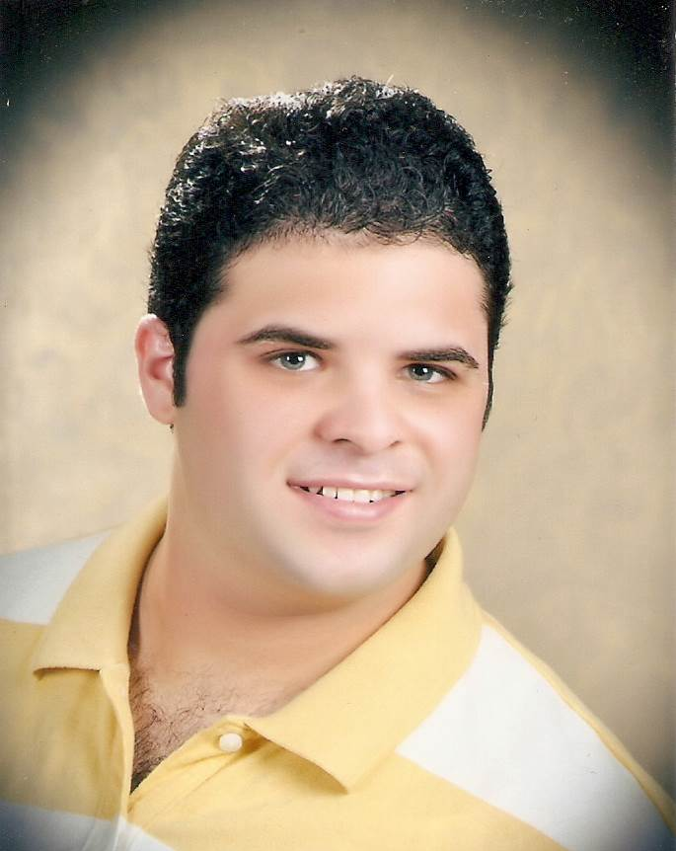
Contact Information
Email: ahmed.ouf1076@gmail.com.com
Mobile: (+2) 01228007888
Address: 73 Saa’d Zaghlol and El Shaheed Mokhtar Saeed St., Flat "47"
Port Said, Egypt.

Ahmed Ahmed Fouad Ouf Hamada

Personal Information | Nationality: Egyptian  Birth Date: October 25, 1988  Marital Status: Married  Military Status: Finished on March 1,2013  Driving License: Egyptian license is Valid
Objective | Seeking a job to improve my personal skills, an opportunity to work to take up managerial position in the field of Civil Engineering and take challenging, creative and diversified projects.
Education | Bachelor of Civil Engineering/ June 2011  Port Said University  Grade of B.sc: Good  Graduation project: Foundation  Grade of project: Excellent
Relevant courses | ➢  Had Satisfactorily Completed " Diploma In Civil Engineering 2010"  at "Yat Learning Solutions"  ➢  Had Attending The Requirements of "The Works Of Isolation In The  Construction Buildings" at "Rashed Al Rashid Trading Est."  ➢  Had Attending The Requirements of "The Preparatory Works For The  Construction of Buildings" at "Engineers Syndicate in Port Said."  ➢  Had Attending The Requirements of "Electrical Work For Buildings" at  "Engineers Syndicate in Port Said."  ➢  Had Attending The Requirements of "Roadworks" at  "Engineers Syndicate in Port Said."  ➢  Had Satisfactorily Completed " Diploma In Etabs , Safe , Sap 2000"  at " The American International Academy "
Experience  2008  2009  2010  2011  2013  2014-2015  2015-till now | Summer Training  Participated as a Site-Engineer at ( Interbuild For Construction Of Buildings ).  Summer Training  Participated as a Site-Engineer at ( El Benaa El Hadith Company For Contracting).  Summer Training  Participated as a Site-Engineer at ( El Benaa El Hadith Company For Contracting ).  Participated as a Site-Engineer at ( El Benaa El Hadith Company For Contracting )  In residential tower at Port Said.  Participated as a Site-Engineer at ( El Masria Company For Contracting And Real Estate Investment )  In residential tower at Port Said.  Participated as a Site-Engineer at ( Osool For Contracting Company )  In residential tower at Port Said.  Participated as a Site-Engineer at ( Diaa Consult For Engineering Consulting And Services )  In 43 apartment buildings at Port Said and 120 apartment buildings for social housing at portsaid and an hotel for portsaid university " a lounge for the doctors "C
Computer Skills | ➢ AutoCAD 2D  ➢ SAP 2000  ➢ Etabs  ➢ Safe  ➢ Primavera Project Management  ➢ Office (Word, Power point, Excel)
Technical visits | ➢ Al-Zamil Steel Factory.   ➢ Misr El Nour Co. For Marble and Granite.   ➢ Misr El-Nour Co. For U.P.V.C .
Language | Arabic: Native.  English: Good command of spoken and written.  French: Fair knowledge.
References | Available upon request.

