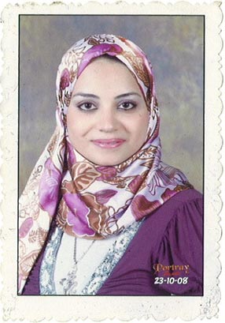Reem Mahmoud Sherif

Mobile : 01280799437

. Mobile 01100587776

.

Home tele: 0403342462

Reemsherifr@yahoo.com

Education

B.Sc. of Commerce , English section, Tanta University, May 2007

Skills

Computer skills:

**Operating system:** Using Windows 98, Windows XP, Other operating Systems Excellent Usage of Ms Office 2000

( Word, Excel, Access, Power Point & Internet ).

Courses

- Course of English conversation at AUC.

- Courses of ICDL at ITC Academy.

-certificate in computer studiesn from tanta university in windows ,

Word , excel and power point .

-certificate from Hi-Q academy at ( team work & interpersonal skills) and ( business communication & writing skills ) and ( people management ) .

Experience

- Training in National Societe Generale Bank from 1/8/2006 to 31/8/2006

- Working accountant at Egyptian Canadian for drugs

Trading from 1/3/2007 to 12/10/2009

-worked at al-shayaa international company

In ksa in multiple brand in customer are and auditor from 10/12/2009 to 1/1/2012

.making now social insurance and pensions governmental from 2017/10/01 to 2018/09/30

Personal Information

|  |  |  |
| --- | --- | --- |
| **Nationality** | **:** | Egyptian |
| **Date of Birth** | **:** | February 15, 1986 |
| **Gender** | **:** | Female |
| **Marital Status** | **:** | Married |

Personal Skills

* Able to work on own initiative and as part of a team
* Good organizational skills and has a good eye for detail
* patient