Personal Information:

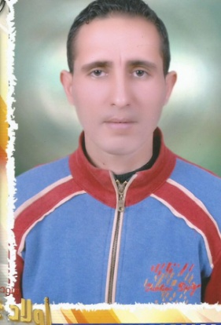

**Name** : Reda Elshahat Reyad Abou Seif .

**Address** : Egypt,Elbehira,Eldelingat,Abou Seif .

**Cell Phone** : 002-01229216492

**E-mail** : reda.elbazy@yahoo.com

**Date of Birth** : 15\3\1986

**Nationality** : Egyptian .

**Gender** : Male .

**Marital Status** : Single .

**Military Service** : Exempted

Education:

*.*

**Faculty of Engineering_(Alexandria University,Egypt) .**

**Department** : Bachelor Degree in Electrical Power

Engineering .

**Year of Graduation** : 2016 .

**Graduation Grade** : Acceptable .

**General Graduation Project**  : Designing of Electrical Distribution

for industrial Plant .

**Graduation Project Grade**  : Exellent .

Skills:

- Exellent computer skills&very good researcher.

- High communication skills,good presenter&ability to

deliver informations .

- Team player,high punctuality,hard worker&handling

Responsibilities

|  |
| --- |
| Programming: |
|  |
|  |

Programming:

- Electrical autocad.

- Dialux.

- etab.

- C programming.

- Avr programming.

- EKTS.

- Symatic manager.

- Matlab programming.

- Microsoft office.

Language:

**Local language** : Arabic .

**English** : Good .

*.*

Professional Qualifications: :;l:qqqqqqqqqQualifications: ( Training )

-Alexandria- Muharram Beck- Electric Production Company.

-Programming micro controller Avr in Jelecom-Alex Company .

-Classic control (self study) .

-training course in Drives and Motors at ETA Academy.

Experience

-Maintenance control and power electrical engineer In a paper factory for 2year.