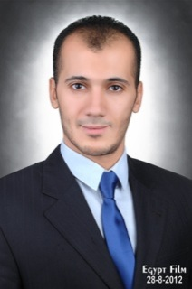

**Personal Information**

|  |  |  |  |
| --- | --- | --- | --- |
| **Surname:** | **KHATER** | **Date of birth:** | **August 12th 1988** |
| **First name:** | **Mahmoud** | **Place of birth:** | **Tanta** |
| **Sex:** | **Male** | **Nationality:** | **Egyptian** |
| **Marital status:** | **Single** | **Education:** | **Faculty of English Commerce** |
| **Military status:** | **Finished march 2011** |  | **Accounting department (good degree)** |
|  |  |  |  |

|  |  |  |
| --- | --- | --- |
| **1-Accountant at water land CO. for marine trips (Werner Lau diving centers SHARM ELSHIKH)since MAY 2011to MAY 2012**  **2-Accountant at marseilia group since 1/2013**  **To 1/2014**  **3-sales representative at at marseilia group since 1/2014** |  |  |
|  |  |  |
|  |  |  |
|  |  |  |

|  |  |
| --- | --- |
| **Language Skills** | **Computer Skills: COMSYS ACCOUNTING SOFTWEAR,** |
| **Arabic “Native Language”** | **Office Applications “Word, PowerPoint, Excel, Access”** |
| **English “Spoken and Written”** | **Internet Fundamentals** |
| **HOBBIES:FOOTBALL,SWIMMING,DIVING,READING,TRAVELING** |  |

**SKILLS&HOBBIES**

**ICDL course (HI Q ACADMY)**

**ADVANCED ENGLISH COURSE (HI Q ACADMY)12\16 LEVEL**

**Courses**

|  |  |  |  |  |
| --- | --- | --- | --- | --- |
| **MAHMOUD RAMDAN KHATER** | **Cellular:** | | **002 01226664848** | |
| **ELGLA .ST .TANTA** | **MSN:** | | [**Ma7moud.khater@hotmail.com**](mailto:Ma7moud.khater@hotmail.com) | |
|  | |  | |  |
|  | |  | |  |

**Contact Information**

**Work Experience "Summer Work&Training**