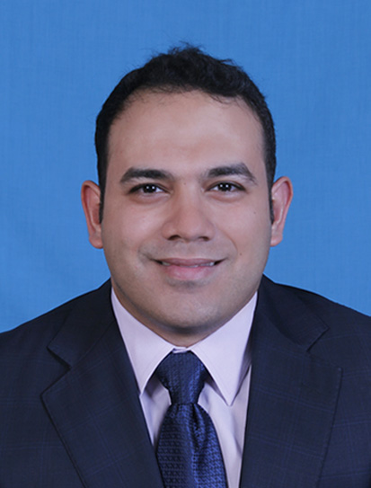
NAME: Ibrahim .Mohamed TAHA
DATE OF BIRTH: 7/19/1985
Nationality: EGYPTIAN
Marital status: Married
Personal number: +201275055545
E-MAIL:Mohammed.taha59@gmail.com

Skills:
1-recording data in journal and ledger
2- Preparing the trail balance, income Statement and balance sheet
3-financial reporting and handle in forecasting process
4-Excellent organization skills
5-Excellent people skills
6-Excellent Accounting System
7-Candidate Cma
8-Ablity to do multi tasks at the same time
9-Good Communication Skills
10- Computer Skills

EGYPTIAN FEDERATION FOR CONSTRACTION - ELHAZEK [EGYPT]
SENIOR Accountant FROM MARS 2019- PRESENT
1- Making the necessary extracts for subcontractors and suppliers
2- Calculation of transaction costs and cost allocation for different projects
3- Prepare the periodic reports necessary to monitor project costs
4- Performed daily entries record
5- Recording banking accountant and making reconciliation
6-FOLLOWING GL LETTERS AND MAKING THE NECESSARY ADUJUSTMENT

EGYTC FOR TRADING AND CONTRACTING. [EGYPT]
SENIOR Accountant FROM DEC 2018- MAY2019
1- Making the necessary extracts for subcontractors and supplier
2- Calculation of transaction costs and cost allocation for different projects
3- Prepare the periodic reports necessary to monitor project costs
4- Performed daily entries record
5- Recording banking accountant and making bank reconciliation monthly

West gulf group. [Qatar, Doha]
SENIOR Accountant Jan 2009- 2018
- Performed accounts payable functions for expenses
- Managed vendor accounts, generating weekly on demand checks
- Managed financial departments with responsibility for Budgets, Forecasting, Accounts Payable and Receivable
- Ensured compliance with accounting deadlines
- Prepared company accounts
- Prepared treasury accounts
- insurers and solicitors regarding financial transactions
- treasury teller
- Make deposit process for company revenue

Zodik Cooperation [Egypt, Cairo]
Accountant, Mar 2007- May 2008
Responsibilities:
- Performed general office duties and administrative tasks
- Prepared weekly confidential sales reports for presentation to management
- Managed the internal and external mail functions
- Provided telephone support

NSGB BANK [Egypt, Cairo]
TELLER training 6 months
- Ensure customer satisfaction at all times by providing cash services in the most expeditious manner.
- Build and maintain strong and effective relationship with branch customers and all other related units of the Group to achieve goals/objectives.
- Process transactions (cash, checks, remittance requests, credit card and loan payments etc) in compliance with the approved policies/ procedures and the applicable regulatory guidelines.
- Balance currency, coin, and checks in cash drawers and prepare the requisite report at the end of the day

Education
Tanta University
Bachelors in Commerce, 2001/2006
- Major: Accounting

COMPUTER SKILLS:
Microsoft Word, Excel, Access, PowerPoint,peachtree. Outlook Express, Microsoft Windows XP and Microsoft Office XP Professional.
Pioneer system-Compact system

