C.V

Esraa Saeed Abd Elazem

Personal Data:

Birth Date : 15/4/1992
Nationality : Egyptian
Marital Status : Single
Residence : 19,st Dr.shawky from ,Elnady ST
,Tanta, Egypt
Email : esraasaeed07@gmail.com
Cell No. : 01020157090

I would appreciate an opportunity to discuss with you how I might best meet your needs.
Thank you for your consideration.
Regards,

- Education:

Degree : Faculty Of arts media department
Graduation grade : Good.
University : Tanta

- Spoken Languages:

Arabic (Fluent Writing and speaking mother tongue )
English (very good)
French ( good )

- Work experience
- Customer service at Te-Data
- call center in orman
- Network marketing at Swaqny
- Customer service & Marketing at El sfawa Laboratory
- Customer service & Marketing at Life laboratories

- Personal skills:

- Highly motivated
- Strong organizational & time management skills
- Ability to work under pressure
- Fast Learner
- Self motivated, dependable and goal oriented
- Good presentation & communication skills
- Ability to work individually and as a cooperative team member

- Computer Skills :
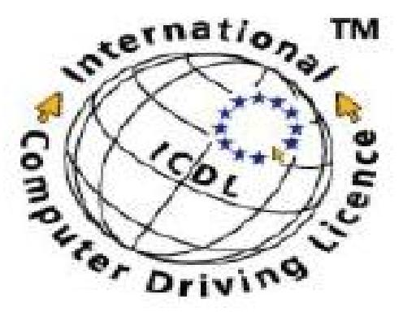
  - Very good at internet navigation and e-mail software
  - ICDL certificate .

- Objectives:

Seeking a responsible position in a company where my experience accomplishment will allow me the opportunity for growth and further experience

I hope to join a reputable company as yours

