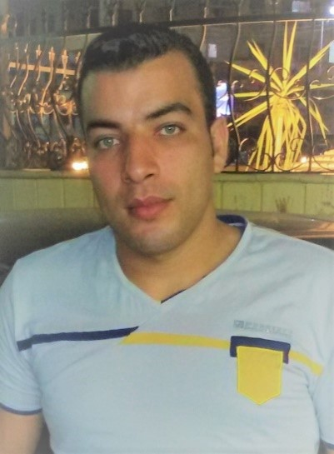**Mohamed Taha Elkotb Radwan**

**Birket elsabe – monufia – Egypt**

**01069341352** / **+966546949670**

[**Engmohamedtaha.c.v@gmail.com**](mailto:Engmohamedtaha.c.v@gmail.com)

**Personal profile:**

A friendly , Quiet person , I love my job field , I want to be civil engineer   
 famous to all the world , like to work in team , don't like problems in work,   
 respect my leader and respect my colleagues in the same place .  
 my aim is to be the best civil engineer and Pray to Allah to achieve my aim .  
  
**Qualifications :** **Bachelor of CIVIL engineering ( 2016 ).**

**overall Assessment >>>** **very good**

**graduation project >>>**  **Excellent**  
  
**Employment history:**

**Site Engineer at Al Deeb Construction Company  
  
 Site engineer at Jalal Al Ali Contracting Est "sudia"**   
  
  **may 2015 : " civil site engineer "  
  
 February 2016 : " Diploma of Structural design "  
   
August 2017 : " Technical office Engineer "  
  
OCTOBER 2018 : " SAFETY & HEALTH DIPLOMA ( HSE ) " .  
  
 Skills :**

**- certified standards of ( OSHA ) construction (30 HOURS ) .**

**- certified standards of ( OSHA ) general industry (30 HOURS ) .**

**- certified SCAFFOLDING Inspection course .**

**- certified RISK ASSESSMENT course .**

**- certified FIRE MARSHAL course .**

**- certified LIFITING AND RIGGING SAFE OPERATIONS .**

**- certified ELECTRICAL SAFETY COURSE .  
  
 - certified SAFETY MANAGEMENT SYSTEMS .**

**- certified FIRST AID COURSE .**

**Computor Skills :**

**- CCNA COURSE**

**- Microsoft office 2007 , 2010 and 2013**

**- Internet navigation and Browsing**

**- Cad program**

**- Sap program**

**- Etabs program  
  
 - Safe Progrm**

**- Excel Program**

**Language:**

**- English : very Good**

**Personal Data :**

**- Date Of Birth : 17/4/1993**

**- Military service : performand**