Dai Alaa
25/8/1998
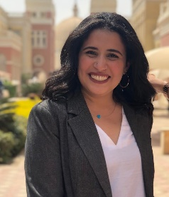 | Abn el Farad street, Tanta  01009133434  Didialaa34@gmail.com  01009133434

PersONAL STATEMENT
Seeking for an opportunity in Accounting and Finance to utilize my skills and contribute. Eager to learn and being my career in this dynamic field.

Education
High school from Dur gems international school in 2016
Graduated from the British University in Egypt in 2020

Internships/Activities

-Trained in the Arab African international bank (AAIB)
-Trained in the Commercial international bank (CIB)
-Joined OMG club for a public relation head member
-Joined Utopians Club for as an organizing member
-Worked as a part time job for Elite construction company

Skills & Abilities
- Experience of working with QuickBooks
- Proficiency in computer skills like Excel, Access, Word, PowerPoint and internet
- Strong in account concepts
- Excellent typing skills
- Mother language Arabic with English as second language

Strenghts
- Excellent communication skill
- Ability to work under pressure
- Enthusiastic
- Harder working
- Eager to learn
- Work oriented person
- Positive thinker
- Sharp minded
- Practical thinking
- Responsible

