Dedicated and experienced accounting professional with proven success managing finances for mid-size commercial organizations. Seeking an opportunity to use my experience to serve work







CONTACT

GAMAL HASHEM ABD ELHAMEED

HASHEM ELKANWATI

ghashem779@gmail.com

00201022909077

MET GHAMR-DAKAHLIA



OBJECTIVE

01/2009

-

02/2010

WEDIAN Securities Brokerage Company

EXPERIENCE

Accountant

Responsible for customer accounts and treasury

|  |  |
| --- | --- |
| 03/2010 - 08/2011  10/2011 - 08/2018 | ElBARON RESORT SHARM ELSHIEKH HOTELS  Cost Accountant  Doing cost analyzes and preparing budget reports  Planning variable costs and fixed costs  Bin Ateeq General Contracting(Saudi Arabia) Jeddah |

GENERAL ACCOUNTANT&CHIEF ACCOUNTANT

Implementing the approved financial and accounting procedures

Control of the issued and incoming documents

Preparing monthly adjustments

Preparing financial reports at the end of each time period

Providing all the information needed by other departments

Financial reporting at the end of each period

2008

Banha university

EDUCATION

Bachelor (faculty of commerce) section (accounting)

Pass

Team building

Problem solving

Decision making

Leadership

SKILLS

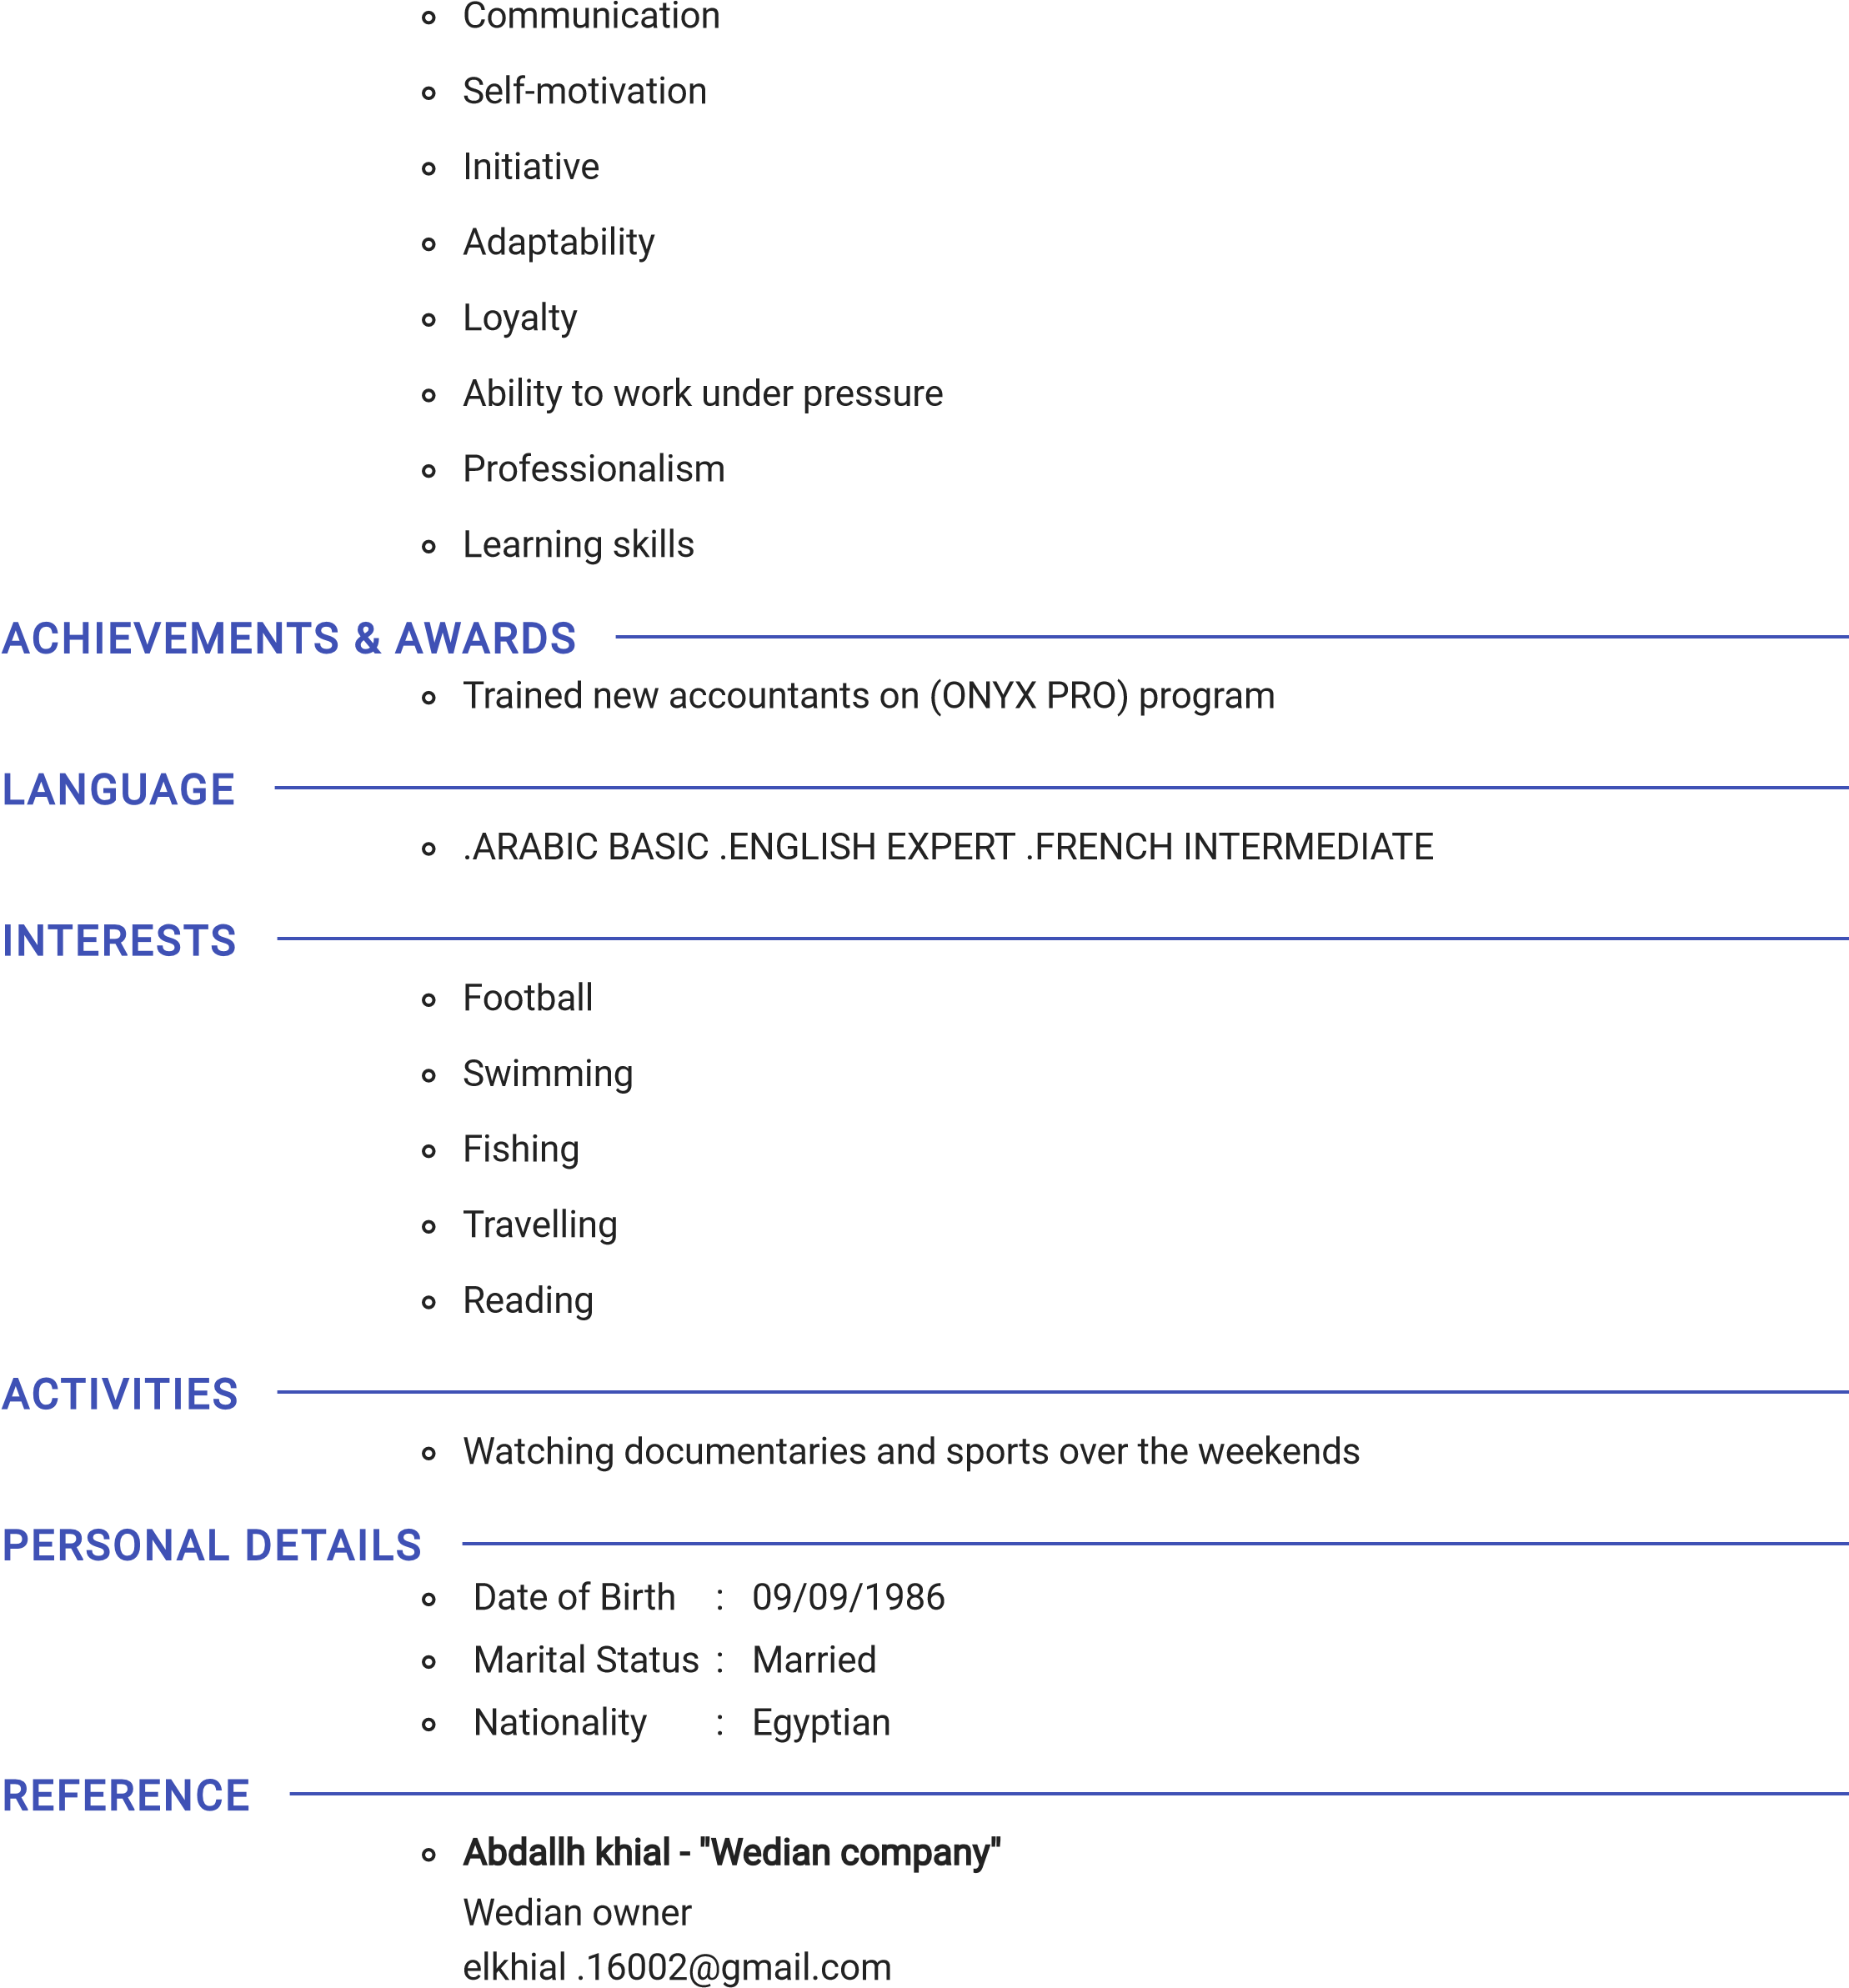

01003010059

Atiq Elzahrani ~~-~~ "BIN ATIQ"

Bin Atiq owner

00966500018630

ADDITIONAL INFORMATION

# hold ~~a~~ B~~a~~chelor's degree in Accounting since 2008 with tr~~a~~ining

|  |  |  |  |  |
| --- | --- | --- | --- | --- |
| exper | ience of more th~~a~~n 11 ye~~a~~rs, | in m~~a~~ny l | ~~a~~rge comp~~a~~n | ies such |

# ~~a~~s (Bin Ateeq Gener~~a~~l Contr~~a~~cting) in the Kingdom of S~~a~~udi Ar~~a~~bi~~a~~ & working on the (Onyx Pro) program and the company (Wedian Brokerage in Securities)

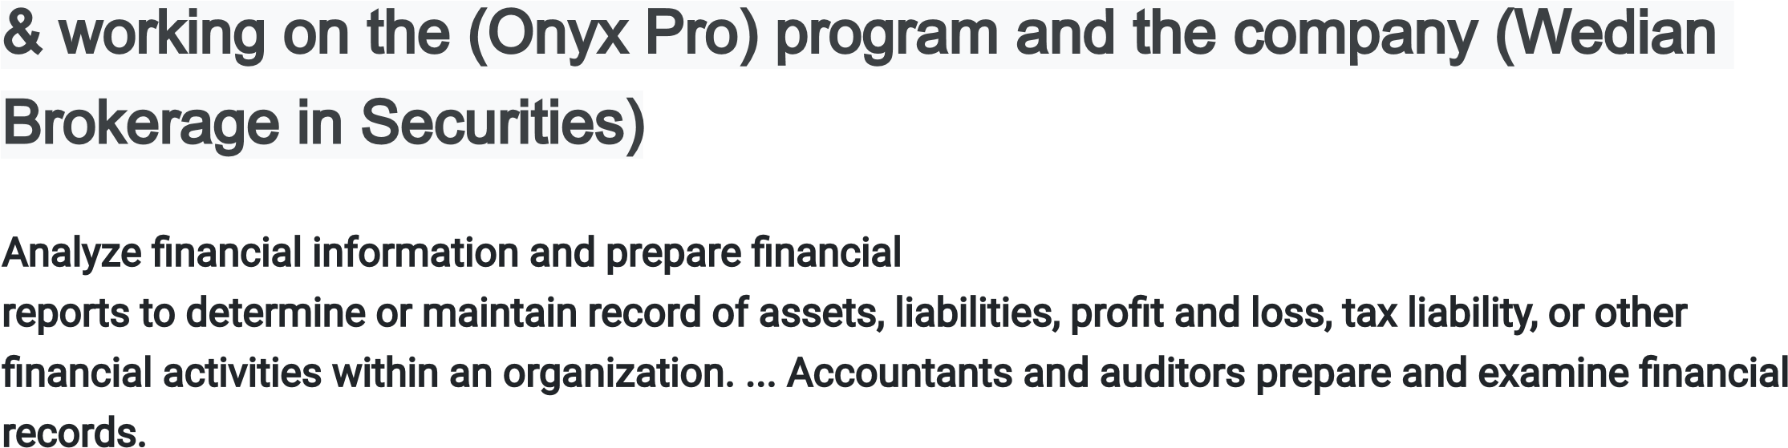Analyze financial information and prepare financial reports to determine or maintain record of assets, liabilities, profit and loss, tax liability, or other financial activities within an organization. ... Accountants and auditors prepare and examine financial records.