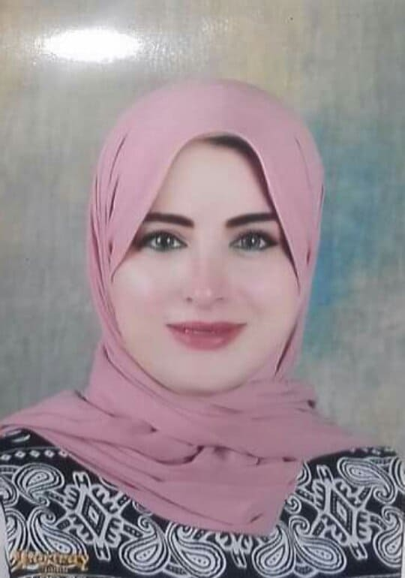

Mona Mohamed Farouk Kandel Cell: 01270795350
3 maehad tawakal st,elAStad, Tanta monakandel231@gmail.com
Age:30 damsel (Single)

Objective:

Seeking a challenging position in the accounting field which utilizing my qualifications, ambition & skills, with the potential for continuous growth, offering excellent work proficiency, gaining more experience and getting new concepts.

Education:

Bachelor of Commerce ,Accounting Department in May, 2011
Faculty of Commerce, Tanta University
Grade : Good
Experiences:

- Sales at sorouh company of 2019 to 2020
- Marketing at united company of pharmacists(HO group) from Des 2018 to 2019
- Marketing and accountant at Delta towers company from Feb 2015 to Nov 2018
- Call center and accountant progame (SAP) at Pharma over seas company from Sep 2013 to Feb2015.
- Customer service and accountant at (Delta Integrated Solutions Xerox business Partner) from Aug. 2012 to Sep2013.
- Junior accountant at (Al youssef for Medical Supplies) from Feb 2012 to Jul 2012 .
Additional Information: (skills and future goals)

Language Skills:
Arabic mother tongue
Good Command of the English Language (Written & Spoken)
Computer Skills:
Computer Literacy
International Computer Driving License (ICDL Certificate)
Soft skills:
      - Presentable, Ambitious, Team player
      - Effective in time management
      - Independent and fast learner
      - Ability to work under stress
      - Self-confident and motivated

