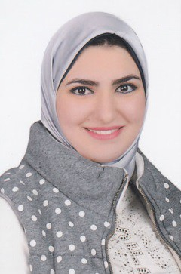

**Yomna Hafez Mostafa Shaban**

**15 El shatr El khames,** **Nerco, ElMaadi, Egypt**

**Telephones : +2-010-60942869 (Mobile)**

**Email**

**Email**

**:** [**yomnahafez2@gmail.com**](mailto:yomanahafez2@gmail.com)

**:** [**yomnahafez271@yahoo.com**](mailto:yomnahafez271@yahoo.com)

***Personal Data***

**:** Egyptian

**:** Single

**:** Female

**:** Muslim

**:** 3/6/1996

***Education***

**:** University

**:** Faculty

**:** Graduation year

**:** Grade

: Tanta University

: Commerce

: 2018

: Very Good with (Honor)

***Other Courses***

: General English

***Experiences***

: Accounting Training in Tanta University

: Accounting Training in Accountant Office

: Fresh Graduated

***Trainings***

: Experience Certificate (consultative group for accounting and auditing).

: Certificate of comprehensive Accountant Diploma (consultative group for accounting and auditing).

: Certificate of Taxes (consultative group for accounting and auditing).

: Certificate of Contracting (consultative group for accounting and auditing).

: Certificate of Accounting Excel (consultative group for accounting and auditing).

: Experience Certificate in (Egyptian Accounting Standards 2015)

: Training at Arabian office for accounting on preparing balance sheet, tax report and feasibility study.

: IFR Certificate Program.

: Training at Arabian office for accounting on Financial Statements.

Nationality Marital Status Gender Religion

Date of Birth

***Computer Courses***

✓

✓

✓

✓

✓

✓

✓

ICDL,

Windows, Microsoft Word, Microsoft Excel,

Microsoft PowerPoint, Microsoft Access,

Excel Accounting,

***Business Skills***

: Team Working And leadership

: Communication skills

: Presentation skills

: Work Under Pressure

: Active, Hardworking, serious

***Personal Skills***

* Quick ability to learn.

•

•

•

Self Confidence.

Able to develop good relationships with people. Co-operate with others and enjoy working team.

***Hobbies and Interests***

: Traveling and Visitations

: Listening to Music

: Drawing and Painting

***Languages***

: Arabic

: English

: French

: Fluent

: Good

: Good