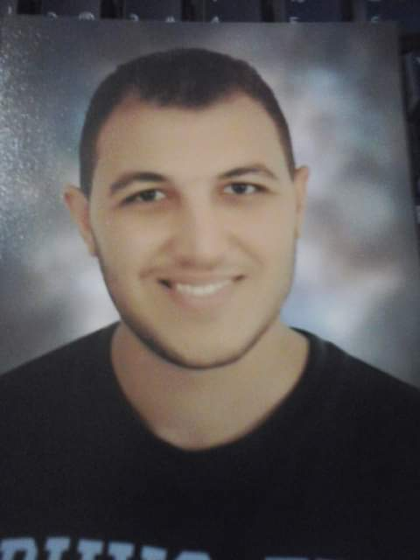
C.V
Personal Information:

Name: Yahia Gamal Ahmed Abo mosalam
Date of birth: 14/5/1994
Gender: Male
Nationality: Egyptian
Marital Status: Single

01069188098 Tel.No :
Address : El-Glaa Street / Mansoura
Email : gamalabomslam@hotmail.com
Education:
- Faculty of engineering El Salab Academy 2016
- Civil engineering (73.5%)
- Project of graduation: Foundation (Excellent)
Courses and Skills:

:

Structural design diploma (Architectural design of land- stratical systems – Auto cad – Etabs – safe – Sap – csi colum – design of different elements according to the Egyptian code of practice).
English (general)
Holding on certificate of ICDL
Qualities:

- The ability to work and adapt with teamwork
- The ability to work efficiently under pressure ,and continuous creativity to achieve to the desired goal.
- The ability to keep up with progresses and developments ,and to adapt and learn what is new in order to achieve the business targets
- 3 Years working as a Egyption Army officer in North Sina

Languages:
:

- Arabic : Mother Tongue.
- English: Very Good.
Special Skills:

- Excellent communication skills.
- Ability to work under pressure.
- Self-motivated, dependable.
- Ability to work individually and as cooperative team member

