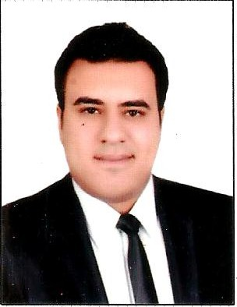

**Amr Magdy El-sayed**

***Tel*** *:* 01005208044

Curriculum Vitae

**Personal Data :**

Birth Date :10/4/1988

Nationality : Egyptian

Marital Status : Married

Military status : Exempted

Address : Mansoura – Dakahlia

**Education :**

* Bachelor of Civil Engineering
* Year of Graduation: 2014

**Experiences:**

* Work as a site engineer at El Nour real estate development (november2014 to may2016)
* Work as site engineer at makkah Construction company(may2016 to Dec2017)
* Work as project manager at Makkah Real Estate Development and construction (Dec2017 to Dec 2018 )
* Work as Consultant Engineer of project (Dar masr elmansoura elgdeda ) from Dec2018 till now

**Computer skills and language**

* Autocad
* Sap 2000
* safe

**Language skills**

* Arabic (Mother Tongue)
* English (Good reading & Writing & Speaking) very good

*Thanks and it'll be very pleasure to join your company*