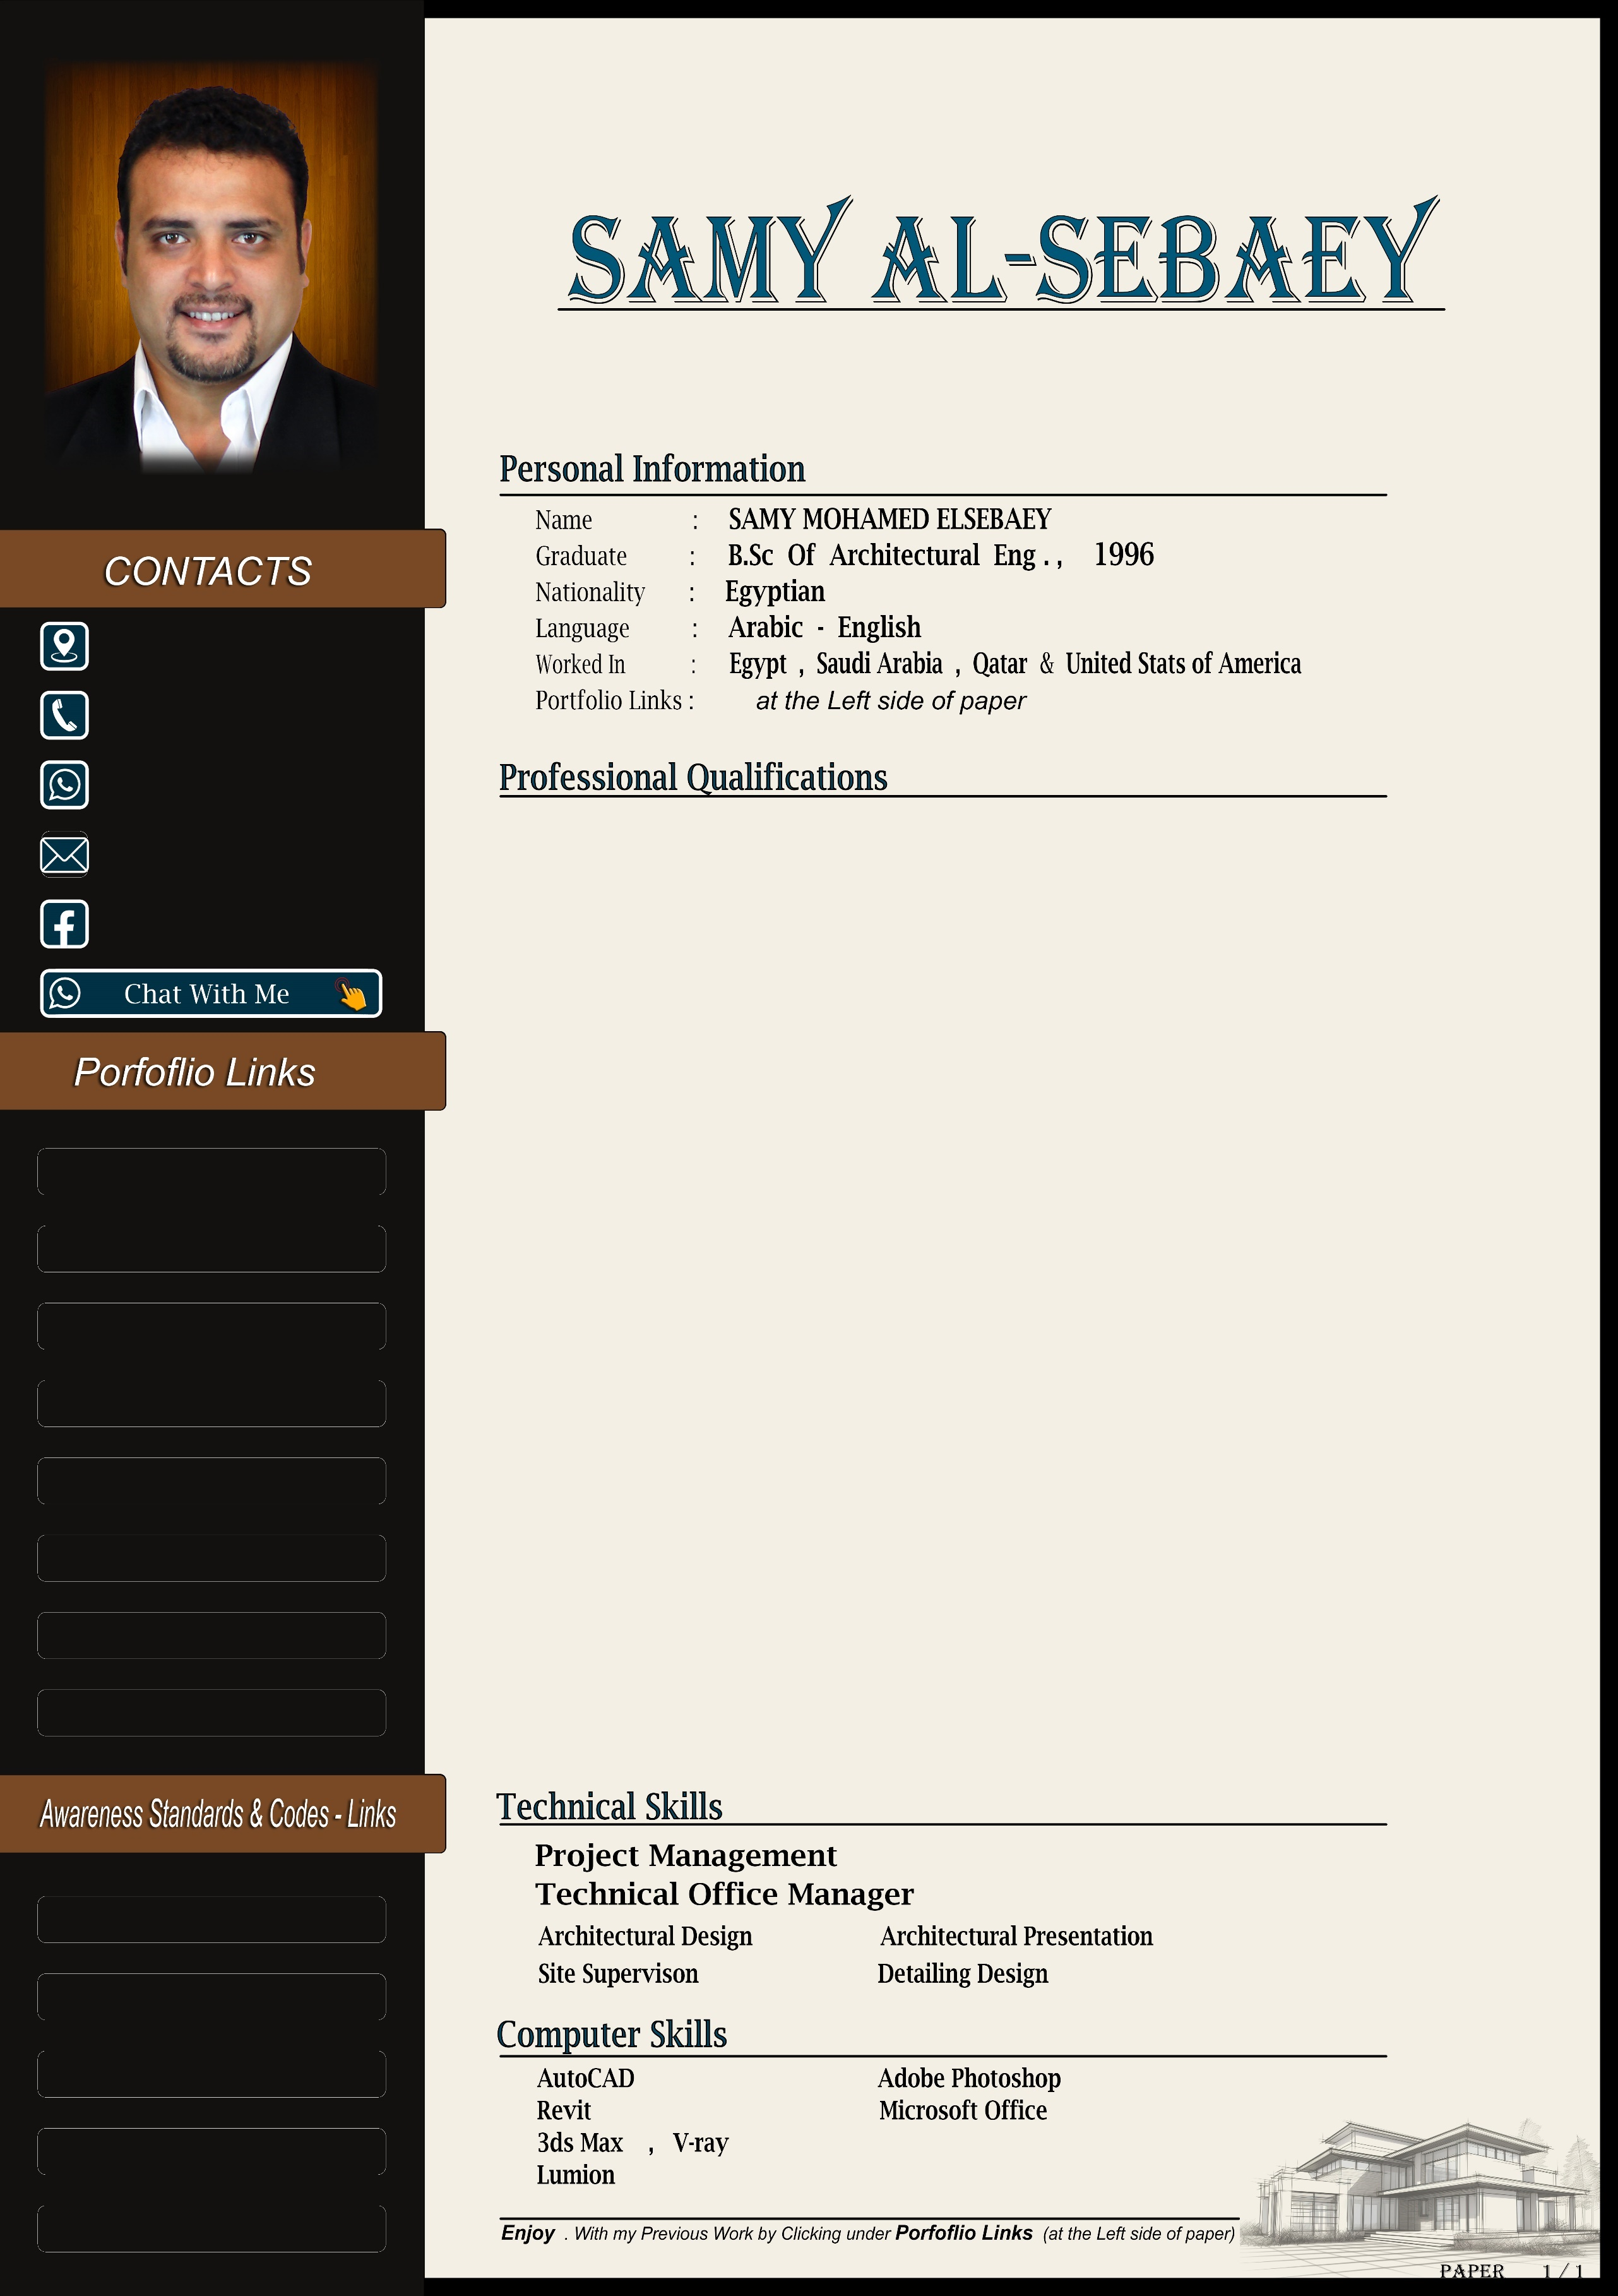










t
CAIRO – EGYPT

+2 012 1277 8474

+2 012 1277 8474

Design3d2030@hotmail.com

Samy Al-Sepaey

Architectural Project Manager

Riyadh – Saudi Arabia

+966 564 898 836

+2 012 1277 8474

Design3d2030@hotmail.com

Samy Al-Sepaey

More than 25 years of work in the engineering sector inside and outside Egypt
(Saudi Arabia – United States of America – Qatar)
I Started my professional life in Architectural dDesign , Architectural Visualization
and Facade Design. With the advancement of years of Experience, I moved to Supervision and Then to contracting.
I Managed a number of Projects as a Supervising and then as an Contractor in the Kingdom of Saudi Arabia ( Petro Saudi HQ - Riviera Hights Compound ). I will not claim that they are Characterized by a large number or Huge size, but as a Natural Result of the Diversity of work and the Diversity of Countries, I Realized the Requirements and Personal skills of the Manager, which I claim that I Acquired, ……. for Example

- Study the Project and have a good Understanding of its Objectives. Develop a work plan for the project, taking into account the project duration, cash flow rates, and other factors.
- Select a Collaborative project team work free of any negative elements and capable of implementing the project.
- Identify and study all external parties associated with the project to maximize the benefit or at least avoid potential negative effects.
- Ability to deal with relevant systems (parent company, technical office, owner, government agencies, subcontractors, suppliers, etc.)
- Build good relationships with all employees characterized by a balance between love, respect, and seriousness, from the lowest worker to the highest authority.
- Permanent and simultaneous supervision with implementation to maximize quality and reduce losses.
- Continuous follow-up with external contractors and suppliers.
- Speed ​​of interaction and developing correct solutions to problems and involving the competent authorities if necessary.



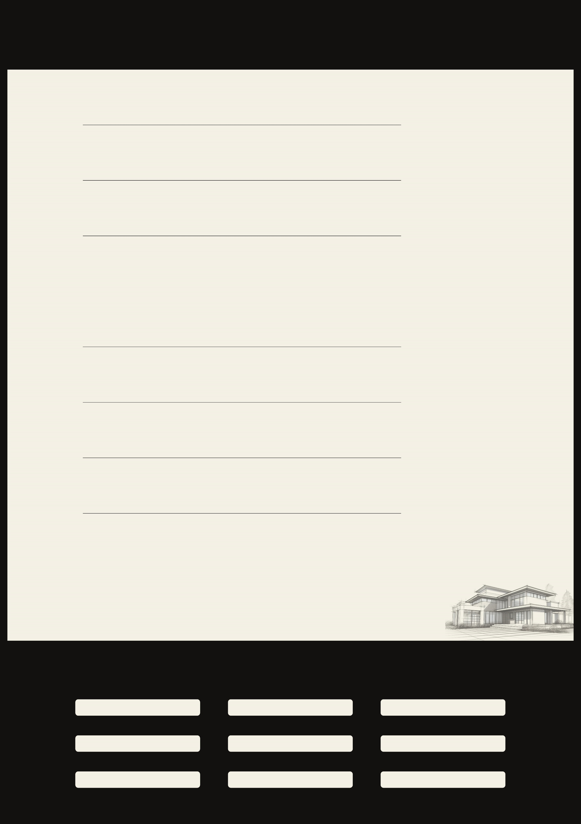
Work Experience

Top Design Engineering Consultant Doha - Qatar
From 2017 to 2022 Architect Design and supervisor
Residential and Commercial Buildings (Villas - G+2 - G+7 - G+12)

AL-Etack for CONTRACTING Riyadh - Saudi Arabia
From 2015 to 2017 Project Manager
( PetroSaudi HQ ) ADMINISTRTIVE HEADQUARTERS BUILDING

Arabian Tourism Development CO. Cairo - EGYPT
From 2013 to 2015 Architect Designer
(Riviera Hights Compound
consists of more than 90 villas - an area of ​​24 acres - close to the
American University Landscape - kid’s areas - international restaurants and
cafes – commercial stores

Saudi Qimam Riyadh - Saudi Arabia
From 2011 to 2013 Architect Designer and supervisor
( CONFRENCE HALL ) ADMINISTRTIVE HEADQUARTERS BUILDING

Cairo Consult Cairo - EGYPT
From 2003 to 2009 Architect Designer and 3d rendering
Residential and Commercial Buildings

Aqtar Consultant Engineering Riyadh - Saudi Arabia
From 1999 to 2002 Architect Designer and 3d rendering
Residential and Commercial Buildings

Wessam Consultant Group Cairo - EGYPT
From 1997 to 1999 Architect Designer and 3d rendering
Residential and Commercial Buildings

Portfolio











